

Ekanayake E.M.B

IT24101737

Exercise

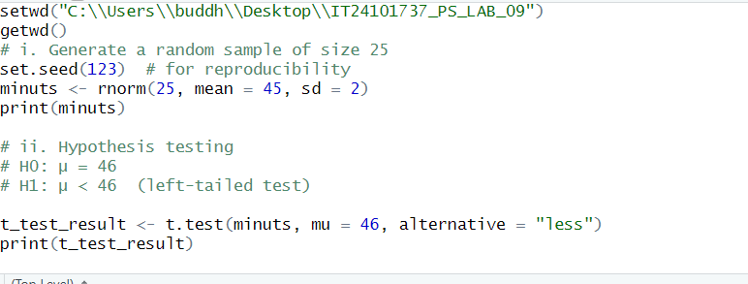

Figure 1.1: R script Question answers

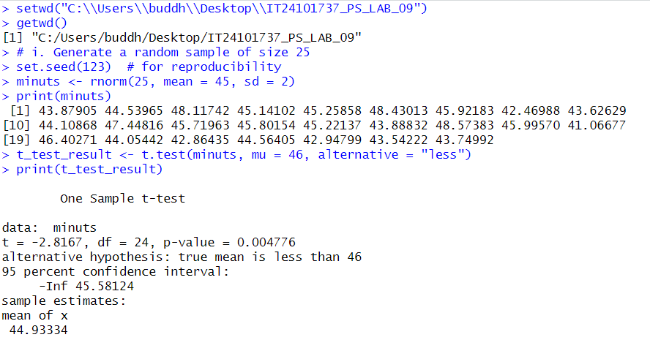

Figure 1.2: console part